Chapter Five: The University of Wyoming Adventure

In September 1963, I flew from Israel to New York City. What a situation I was in at that point. A tall, muscular young man surrounded by suitcases with poor English language skills in one of the busiest and least friendly airports on the planet. I had left the old city of Tel Aviv with its beautiful beaches, the ironical attitudes and joyous laughter, as well as the ten million opinions held by three million Israelis.
The Israel that I had left behind was a very small country, roughly the size of the US state of New Jersey. The shortest distance from East to West is nine miles, near Netanya, where I had attended Wingate College. The longest North to South distance, as the crow flies, is 290 miles. In addition to the shocking size differential was the frantic and unfriendly crush of people at this huge airport complex in New York City. Although I had been here before, it was with Amos and the other athletes accompanied by an English speaking chaperone. This time, however, was entirely different. The people talked and walked at such frenetic tempos that it seemed to my eyes, laden with jet lag, to be just a blur of sound and activity.
In Israel, people got around the country by riding the bus, walking, or hitchhiking. Naturally, I assumed it was the same thing in the US, so I asked an airport worker for directions for the bus to Laramie. Now came the next shock. The fellow told me that Laramie did not exist! He said that it was only a popular American television program and there were no buses going to an imaginary place. Eventually, I found the bus terminal but there were only buses to downtown New York City and none scheduled for Laramie, Wyoming. Now what, I wondered?
A man on the plane had told me that many wealthy New Yorkers needed to move their cars from the East coast to the West coast. The idea was that these individuals would fly in comfort and would hire someone to drive their car. He told me that if I could find someone who needed this service, I might even be paid to drive the car. What a fantastic opportunity this would be for me now that I was stuck 2000 miles from my destination in Wyoming. I did not have a proper driver’s license but this did not deter me, nor, for that matter, the agency I finally located!
I was paired with another young man, a Chinese fellow whose English was worse than mine and believe me that is saying something. We were assigned to drive a large, new, fancy Cadillac from NYC to California. I explained that I would be traveling only as far as Laramie, Wyoming but neither the agency nor the Chinese fellow seemed to understand or care what I was telling them. Of course, now I realize that neither of us had a clue as to where Wyoming was located.
After loading our bags into the trunk of this fine, dark blue car, we set our course due west. Getting out of New York City, with all of its traffic, proved to be the first challenge. Not only was the traffic terrible but it seemed that every driver with a horn needed to honk it. As we crawled slowly along in the escalating noise, I noticed the jitters that my companion couldn’t hide. I asked, in my less than perfect English, if he was all right. To my dismay, he started screaming at the top of his lungs in his native language while pointing ahead. It was unclear whether he was trying to give directions or just shouting about the traffic jam. As I look back at the first few minutes of our three day drive, I should have known that this was not going to be a particularly nice trip.
After we drove out and away from the city, I perceived that he was somewhat more relaxed. In my childhood dreams, I could only imagine driving a Cadillac and now here I was sitting behind the wheel of one! My mind raced as I thought about sending a picture of myself driving this car to my friends that I had left behind. What would Yariv or Yael say, I wondered to myself?
It was not very long before I discovered that the United States was vastly larger than Israel. I had no idea that any place could be so huge! Israel had beautiful landscapes but my entire country could fit into New Jersey. Here in American, there were motorways after highways, hills, green forests, winding rivers, and open lush valley landscapes that seemed to stretch on to forever. This America was so much larger in reality than I had ever imagined when I dreamed my impossible dream staring at my old map in Hadassim. My old map with the elephant in Africa and the family in the Cadillac driving across America did not do justice in depicting what I was now seeing first hand. Here I was, in a Cadillac, and this country was much more vast than I had ever thought possible.
Unfortunately, it had become painfully obvious that the Chinese fellow was quite nervous and easily irritated. He never wanted to make comfort stops and constantly ranted in Chinese. Eventually he dropped me off at a bus station in South Dakota, near Mount Rushmore where the presidents’ heads are carved into the mountain.
I had never seen such a huge carving and, once again, was impressed by the vastness of America. South Dakota, with its mountains and Badlands National Park could have been the moon for all of its unique, but completely unfamiliar landscape! I finally boarded a bus for Laramie, Wyoming and I remember thinking that at least this part of my journey would be peaceful and relaxing since I was rid of eccentric Chinese behavior. At least in South Dakota, the bus station attendant knew that Laramie was a real place and not some television locale. I had to change buses in Cheyenne and, after 6 hours of riding, arrived in Laramie. I was relieved that Coach John Walker was there at the bus station to pick me up.
I stared at the town and the surroundings as we drove in Coach Walker’s car. I had never experienced beauty or grandness like this. Until this moment, I had only known the warm Mediterranean sun and small hills, some nearly barren and others covered with olive groves. Even the hills of Greece and Rome were smaller and warmer than these mountains. Everything here was enormous and the Rockies were huge, rugged, and snow capped at their summits despite that it was only September. I had left the warm, almost hot, Israeli climate in my shorts and sandals. This climatic change was another shocking eye opener for me and for my body as I stepped out into the Wyoming temperature of 43 degrees!
Coach Walker’s first stop was at Sears to buy a proper coat for me or I might have frozen to death. I noticed that all the people walking around were also big. In Israel, people were relatively small. I was, at 6’1’’, considered tall, by Israeli standards. When I looked around the store in Wyoming, all I saw were big hats and blue jeans on big people and felt that I had been transported into one of those Western movies I used to watch in Israel. Coach Walker was very kind to me that day. He bought two pairs of blue jeans and some sweat shirts embroidered with the University of Wyoming insignia on them. The most important purchase was a heavy, warm coat which was something that I never owned or needed in sunny, hot Israel. He insisted that I choose a coat that fit loosely. At first, I didn’t understand the reason for a loose fit since my urge was to snuggle into the material hugging it close to my body for warmth. He explained that when it gets really cold I would need room to add more layers of cloths underneath for added warmth. “Really cold?” I thought. It was really cold now! How much colder could it be? Little did I know the answer to that question was sometimes 20 degrees below zero Fahrenheit? This would be a huge difference from a normal Tel Aviv winter cold of 65 degrees Fahrenheit.
Another thing that I noticed in the Sears store was that I could not understand one word of any of the conversations. The people sounded like cats meowing at each other rather than normal conversations using vocabulary words. Despite my trouble understanding the language and accents, I discovered immediately that everyone welcomed me with a friendly smile and big handshake.
After we left the store with my new clothes, we drove to the University. The University of Wyoming is nestled between two mountain ranges and Coach Walker pointed out waterfalls as we drove to the University. I continued to be amazed, even snuggled in my new warm coat, how cold it was and it was only the beginning of September. But the scenery was truly gorgeous and awe inspiring.
Coach Walker took me to the sports dormitory and introduced me to my roommate, one of the sprinters. The sports dormitory had its own restaurant in the downstairs area since the athletes were fed separately from the other students who lived on campus in the other dormitories. Here, then, was another amazing feature in Wyoming. The food arrived in enormous quantities and was delicious. I was rapidly learning that everything in Wyoming was huge. I was introduced to steaks, BBQ chicken, beef pot roast fried chicken, BBQ ribs, baked potatoes, and a large variety of vegetables that I never even knew even existed. There was always an ample supply of French Fries which I came to love in my early years in America.
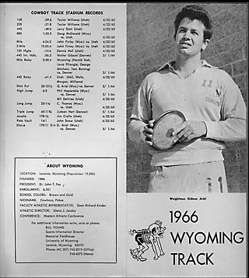
The next day was the first training at the field house. In September, it is too cold to train outside in Wyoming. Laramie is high and the altitude of 7200 feet definitely affected my breathing. Running around the field house was difficult but one of the other athletes explained that this normal and that I would adjust quickly. While the high altitude was a new experience, I rapidly adjusted because I was physically fit before my arrival.
I was given a number of discuses and started throwing in the field house. How I loved the feeling that elevates your being when throwing that round, nearly flat disk. From that point on, my daily life became a regular, predicable routine. The day started with breakfast, followed by the academic classes to which I had been assigned. Initially, I was unable to understand the teachers’ English, but I was confident that eventually I would learn. Classes were followed by lunch, a 2 hour rest period, and then back to the field house for training.
The field house was so huge that all of the sports teams were able to train at the same time. This meant that all of the track and field events and the entire football squad were training under one roof. The football players were the most enormous human beings I had ever seen. I could not believe the size of these athletes. I was amazed at the width and bulk of their shoulders and was surprised that their heads were completely out of proportion to the rest of their bodies. Another perplexing problem was why the University could not afford a round ball. In letters to my friends in Israel, I wrote that I had never seen such giants in my life and how grateful I was that they did not throw the discus. Needless to say, my experiences were with “soccer” which is known throughout the World as “football”. Since I was unfamiliar with the American version of football, I also did not realize that the sizes of the players were enhanced by shoulder pads.
My life continued this way for weeks. One day, however, while throwing the discus at the field house, one of the football coaches started shouting at me. Needless to say, I had no idea what he was yelling nor why. Perhaps my discus had landed too close to the football players’ area but I was throwing in my designated area. I nodded with my head, as though I understood, and continued to throw. The Coach again screamed and ran toward me. Unfortunately, in all of that screaming there was only one thing that I understood which was a curse, “Son of a bitch.” The coach ran up to where I was throwing, waving his arms, ranting, raving, shouting, and cursing the whole time. I wanted to tell him to shut up but, when I went from the Hebrew expression in my head to the English translation that came out of my mouth, I told him to “Close your hole.” For the Coach, this was the straw that broke the proverbial camel’s back. He lifted his clipboard high overhead and brought it crashing down onto my forearm. My military training generated an automatic reaction and I punched him hard in the stomach. He was close enough to me for me to feel the expulsion of his breath blow across my body and I immediately realized that I had hurt him as he crashed to the floor holding his midsection. I also knew that this was not a particularly good thing that I had done. Several athletes quickly stepped between us.
I quickly returned to my room in the dormitory and started packing my clothes and belongings into my suitcase. I was sure this was the end of my college career in Wyoming and probably all of America. There was no doubt in my mind that I would be kicked out after this episode. My heart sank lower as my depression grew. I could feel the tears welling up in my eyes. I realized that my response was a perhaps an overreaction, but my arm still hurt from his blow with the clipboard. After all, he was the one who started the whole mess. I was a visitor studying in his country so it seemed unfair that I would have to be punished.
My underwear was in my bag and I was about to pack my socks when suddenly, I heard a knock on the door. I guess that the police were there to take me away. When I opened the door an older man in his fifties was standing there and started talking to me in Hebrew. Now I was sure I would be returning to Israel since I was starting to hallucinate that Americans could speak English that converted to Hebrew in my ears. The man introduced himself as Dr. Martin Wolman and explained that he had served in the Israeli military as a volunteer in the 1948 independent war. He told me that he heard what happened in the field house and asked to see my arm. I showed him the large gash on my arm made by the clipboard.
He told me, “Gideon, don’t worry, you do not have to leave.” He explained that in America this aggressive behavior toward an athlete was actually against the rules. The coach, in this case, was the aggressor and I was the victim. In America, you are allowed to defend yourself when attacked. In fact, the coach owed me an apology, at the very least. Regardless, I need not worry anymore and I was not going to be sent back to Israel. As he explained these things to me, I sat on my bunk, placed my head in my hands, and breathed a huge sigh of relief. He put his hand on my shoulder and said, “Gideon, your future here is very bright. Do not be discouraged by this event.”
It was then that I learned that Dr. Wolman was the head physician of the University. He took me first to the school infirmary and treated my wound. Then he invited to dinner at his house that evening with his wife and soon we became very good friends. He also showed me his Cadillac, which impressed me greatly at the time. It was much finer than the one that I had driven from NYC to South Dakota. We remained close friends throughout my college years and he was always available to help for years even after I finished at the University of Wyoming.
The day finally arrived for my first meet as an athlete representing the University of Wyoming. This meet was in Denver at the University of Denver and everyone watched anxiously. My performances were awesome that day and I broke both records for the University in the Shot and Discus. Coach Walker was ecstatic with joy.
My English improved more rapidly than expected and I began to do well in all of my classes. My classes for the second semester were more intense than those I had taken during the fall semester. They were more academically challenging and included more of the sciences, such as Physiology, Chemistry, and Physics. The professors liked me and were impressed with my intense efforts to understand the material. I would go to each professor when I needed help and then immediately go to the library to get the extra books they had recommended. They were also very approachable when I had questions or needed help with some difficult concept. I think many of my problems were language related, but the teachers were always willing to help me. I was studying hard in school and training intensely in the weight room and throwing on the field.
There was only one problem and that was loneliness. I believe that some of this loneliness was because I was older than most of the members of the Track Team since I had served the extra 3 years in the military in addition to the two years of college at Wingate. I was 24 years old whereas the average Wyoming student was between 18 and 20 years old. I missed Israel and the camaraderie of my friends.
One day, during training, I told Coach Walker that I thought I should go back to Israel. He asked me why and I told him how alone I felt and that I missed my friends. He asked me if I had a friend, who was also an athlete, and who would be willing to come join me and compete for the University of Wyoming. I immediately thought of one of my best friends, Gilad Weingarten, who was an excellent long jumper. I told Coach Walker about Gilad and, without hesitation, he told me to bring Gilad to Wyoming.
Coach Walker said I could call from the phone in his office. I rushed in and called Gilad in Israel. I paid no attention to what time it was in either location.
“Hello Gilad, this is Gideon.”
It was turned out to be in the middle of the night in Israel so, of course, I woke him up from a deep sleep. “What? Are you crazy?” he said. “Do you know what time it is?”
I ignored his question and continued undeterred by his questions. “Listen. Would you like to have a full scholarship, like I have, to the University of Wyoming? This would be an unbelievable opportunity for you to achieve all of the goals we talked about all these years while we were on the same team in Israel?” Gilad was in shock or maybe trying to wake up and determine whether this was a dream or really a call from me in America.
After a moment of silence he asked, “What’s the weather like in Laramie?”
I tried not to think about my coat around me when I traversed the campus in the snow and replied, “It’s just like Israel.”
Gilad agreed to come for the semester beginning in January 1964. Coach Walker sent him an airline ticket. I waited for Gilad with Coach Walker at the bus station just as he had for me only a few months earlier. The bus arrived and Gilad was dressed in the same fashion as I had been wearing only a thin shirt with short sleeves, shorts, and sandals. Unfortunately, the day Gilad arrived, the temperature was 50 below zero. When he stepped off of the bus, he gasped for breath in the frigid, mountain air.
“What do you mean the weather is just like in Israel? How could you lie to me?” he was finally stammered as he shivered in the cold.
I replied, “When I was talking to you on the phone, it was 70 degrees.”
He shook his head in exasperation. But to my great joy and relief, Gilad was here and I would not be alone any more. We had been such good friends, hard-working athletes, and shared many common experiences in Israel, so I knew he would forgive me eventually for the climate. Picking up his suitcase, we went to buy some winter clothes for my frozen friend, Gilad.
Gilad and I lived in the same sports dormitory designated for athletes where I had been housed. Our room was on the same floor as the football players. Unfortunately, the track and field athletes and the football team did not share overlapping competitive seasons. In the fall, it was football season and in the spring, it was track and field’s turn for competitions. Thus the football players had more regulated sleep schedules during the fall months until Christmas. The reverse was in effect during the spring semester. Following the Christmas break, the track and field athletes had their more stringent rules regarding curfews and lights off at night. At the same time, the football players no longer were subjected to rules regarding sleep. Therefore, these off-season athletes would stay out late on Friday evening and, when they returned to the dorm, there was loud shouting, screaming, music, and noise until all hours.
During the spring semester, Gilad and I normally had a competition every Saturday and this tremendous noise interfered with our ability to sleep. One of us would have to get up and go out to the area where the football players were having their noisy parties and ask them to please to be quite.
“Do you mind keeping it down? We have a meet tomorrow.”
“Okay, ‘G boys’. ‘G boys’ was their affectionate name for us. The players were always agreeable and then they would open another beer. Within minutes the noise level would be just as raucous and loud as it had been before we asked.
Gilad and I decided that we needed a solution for our problem. The following Sunday morning, at 5 o’clock, Gilad and I wrapped towels around our heads, like Indian swamis. Then we sat crossed legged on our beds, closed our eyes, and started screaming loud, strange, and exotic noises at the top of our lungs. The sounds were deafening and we woke everyone on the hall. As the players were startled awake at this early and unholy hour, they groggily went downstairs to the supervisor on the first floor for help.
The supervisor sleepily came up stairs and knocked on our door. We continued to shout and scream at unbelievable high decibel levels. Finally, the supervisor tentatively opened our door and saw us sitting in our Yoga positions while we screeched and wailed.
“What are you doing?” the supervisor asked us.
“We are praying,” we answered.
“Can I talk with you guys after you finish your prayers?” he asked.
We only nodded and continued our loud prayers.
After a reasonable period of time, we ceased praying and we went to his office. The supervisor was a very nice man who liked both of us. He explained that our prayers were quite loud and woke everyone on the hall and inquired whether we could change the time or the location for our services. We told him that if we were able to sleep in undisturbed quiet on Friday nights, we could probably accommodate the sleeping comfort of others on the hall on Sunday morning. He quickly understood the situation and assured us that he would explain to the football players that loud noises on Friday night resulted in our intensely loud prayers on Sunday morning. Quiet on Friday night meant quiet on Sunday mornings.
Friday nights were quiet after that. Once in a while, we would hear the players coming in late and if anyone made any noise, someone would say. “Shshsh, the G-Boys are sleeping. Don’t wake them up or they’ll start praying.” The first time we overheard this, we burst into uncontrollable laughter.
Gilad and I were continually surprised by America and its many opportunities. For example, when we arrived in the US in 1963 and 1964, we had left a country that did not yet have television. During my first visit to New York City as an exchange student, we had all appeared on the Ed Sullivan Show. But no one in Israel had known about this event. In Israel, visual entertainment was going to the theater for a movie. One day, Gilad and I ventured downstairs in our dorm and discovered that there was a television set available for all of the athletes to watch. What an amazing magnet to draw two naive boys from Israel to see. One evening we were sitting downstairs in the TV room with the others athletes watching a program called “The Fugitive.” We saw a man running with an injured arm and the police chasing him. The following Thursday night, we watched the “Fugitive” program again. Incomprehensible the Police had not caught him yet! America was the greatest country in the World, but the authorities could not apprehend a man with such a terribly injured arm. The other guys laughed at us as we slowly began to realize that this was only a story and not an actual news event.
Another revelation for us was the crazy way the Americans danced at parties. We were familiar with the Waltz, Tango, Samba and, of course, many Israeli folk dances. But at the dance parties we attended, there were bizarre and crazy bodily flailing that looked more like people were being given electric shock treatments than any dance movements which we had ever seen. Girls attending these parties were not going to let two good looking guys just sit and watch, however. We were dragged on to the dance floor and were forced us to learn to dance. Soon we looked like active rag dolls as we twisted and turned.
Gilad and I were older and had experienced much more of life than our friends and colleagues in the sports dorm. We studied and trained with great intensity because this was a one-time chance for our futures and we were going to make it the best opportunity that we could. Eventually, we adjusted to all of the newness of life in the United States. Our participation on the academic and athletic paths became upbeat experiences. Our goals were to graduate and be able to continue in graduate school somewhere in America. We travelled around the country competing for the University and performed well enough to more than justify Coach Walker’s belief in our efforts.
Women chased us for our athletic prowess and good looks. Gilad liked the girls but I was not someone who liked short relationships. Gilad seemed to have a number of short term girlfriends, but none of them were serious in any way. But no matter how much effort we invested in our athletic events or, in Gilad’s case, how many girls he dated, we never shirked our studies. We helped each other like brothers in scholastics, training, and life events. We even combined our resources to buy a 1953 Chevy for $150.
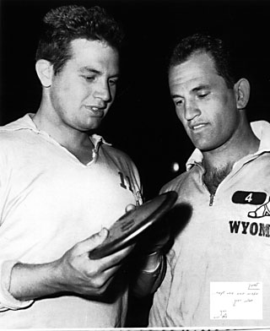
Gilad and I at the University of Wyoming
Although I was much happier now since my best friend, Gilad, had joined me in Wyoming, I still missed Yael. Finally, after many romantic words and equally creative descriptions of Wyoming, she agreed to join me. She landed in New York and took the bus to Laramie. We were able to spend some happy times together but she could not remain in Laramie with nothing to do. I had met a few Jewish families and they offered to help us. One family, the Brodies, suggested that Yael live with them in Denver and, then, I could visit on the weekends. It was a two hour drive from Laramie to Denver, which was not an insurmountable distance, so we all agreed to this plan.
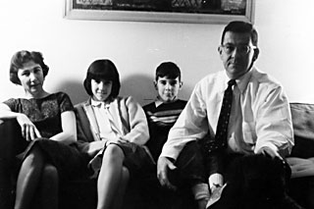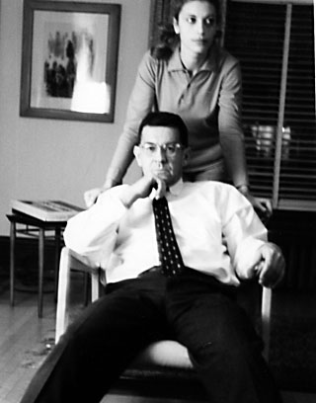
Yael with the Brodie family
On weekends when there were no track meets, I would drive the Chevy that Gilad and I owned to visit Yael in Denver. Unfortunately, Yael had only been granted a visitor’s visa when she initially traveled to the United States. These visas are only good for 3 months which meant that in January, Yael would have to return to Israel.
When I arrived in Denver one weekend in December, Mr. Brodie seemed to have solved the dilemma very neatly. He opened the front door, as usual, and said, “Hi, Gideon. Guess what?”
“What?” I answered with a baffled expression as I stepped into his home. “You are getting married,” he said smiling broadly.
“When?” I asked, in complete shock. I was sure that he was just joking.
“Today.” He answered. He took my coat, and with a ridiculous grin on his face, patted me on my shoulder.
“The only way that Yael can remain in the U.S. is if you two are married. Besides, I know you two love each other. It’s perfect plan, don’t you think?” The smile was now gone and he was being completely serious.
“Does Yael know of this? Did you propose for me?” I had assumed that this was something that I was supposed to do.
“Well, since you put it that way, yes…I guess I did. Fortunately, she accepted without kissing me, though.” he replied.
“Whew! That’s a relief.” As the thought sunk in I realized that perhaps it was a good idea after all. The fact that she already accepted relieve me of the obvious tension and apprehension of actually making the proposal. When I saw her for the first time, she greeted with a big bear hug. I guess she was unsure whether I would agree or not so my acquiescence was a relief.
The Brodie family had arranged the ceremony and even had a suit ready for me. So with the Brody family in attendance, the Rabbi conducted the ceremony and we became man and wife.
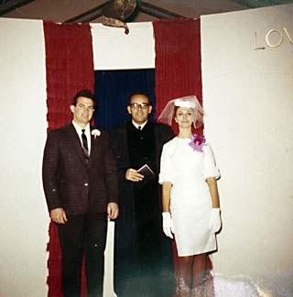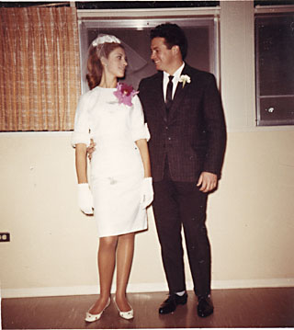
Our small wedding
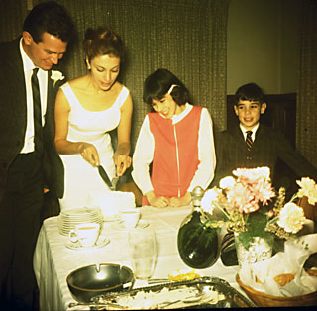
Celebration after the wedding
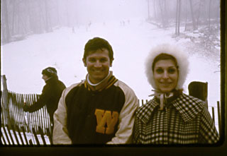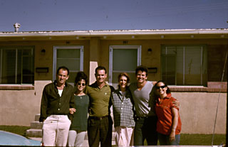
Yael and I at the University Yael at her 8th month pregnancy

I was afraid to tell Coach Walker that I was married since I thought I would lose my scholarship. Yael came to watch one of the competitions during the Christmas season against the University of Denver. I won the shot put throw and then went over to talk to her. Coach Walker called me over and said: “Gideon, leave the girls alone.”
I told him that this was not just some girl that she was my wife. “Your wife??!!!” he exclaimed. “You never told me you are married.”
Thinking quickly, I said to him: “Coach, you told me Merry Christmas, and I always do whatever my coach tells me. So I married at Christmas.”
Until today, I am convinced that Coach Walker thinks that this poor Jewish boy did not understand the meaning of “Merry Christmas”. He thinks he is the one who changed my life and, in more ways than one, he did.
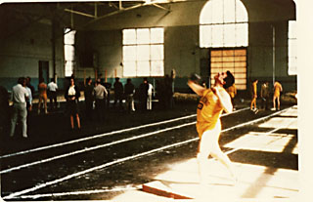

Competing in Denver Colorado
One of the first Track and Field competitions early in September of 1964 was held at a local University in Elbert, Colorado. I amazed everyone, including myself, by throwing the Discus 192 feet 2 and ½ inches. This distance broke both the Wyoming and the Israeli record and was within 13 feet of the discus world record at that time. I was thrilled because now I had a second chance. A second change to go to the Olympics; a second chance to redeem myself after the poor showing I had in Rome. With a throw of this distance, I immediately qualified to represent Israel in the Tokyo Olympics in October 1964. It was a relief and a burden at the same time. This opportunity happened to only a few people in any country and even fewer Israelis are able to have this chance.
There was only one problem, Yael was pregnant. This would not have been a problem except for the baby’s due date. The baby was planning to arrive at about the same time as the Tokyo Olympic Games. Needless to say, Yael was furious and resistant to my leaving to go for this completion. What if she had the child while I was away?
My tickets to Tokyo arrived with the departure date set for October 4th 1964. Of course, on the morning of October 4, 1964, Yael, who was living in Denver, went into labor. One of my school friends drove me to the hospital in Denver. Yael was already there and ready to deliver the baby.
What a difficult choice I faced. I was supposed to catch a flight from Denver that night to Tokyo and Yael was delivering our child. I was frantic, anxious, worried, and perplexed. This was the most difficult choice I had ever encountered.
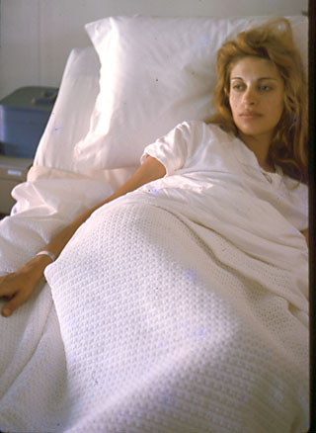
Yael at the hospital delivering our daughter, Geffen Olympia Ariel

At last, our daughter emerged in the afternoon of Oct. 4, 1964. She was a beautiful little bundle and felt so tiny in my arms. She had dark eyes and hair and I was sure that she would grow up to be brilliant and beautiful, as all fathers believe of their babies.
What should I do now, I pondered? Should I cancel my participation in the Olympic Games and stay with Yael? Should I go to Tokyo for my last chance to compete in the Olympic Games since I would never have another opportunity? Yael insisted that I stay. She begged and pleaded. I told her, “Please, Yael, understand that the discus has been my life. I was able to have a scholarship in America because of this discus. I performed poorly in Rome and was criticized by everyone then. You and I will have long years together, but this is the last Olympics for me. I will never be able to compete again in the Olympic Games. I must show my country that I can do better than I did in the last Olympics. I need to show Yariv and everyone who has supported me and believed in me that they were justified in their beliefs.”
Finally, I realized that my choice had to be the Olympics. It was too late to find a replacement discus thrower to represent my country. Plus, I had devoted my life to this activity, it had nurtured me throughout my childhood when only the belief in me by my mentors had given me hope, and it had provided a chance to study in the United States. It was an unfair choice but one that I had to make. In my heart and mind, I believed that Yael and our daughter would be lovingly cared for without my presence for the first two weeks. With these thoughts swirling in my head, I told her that I would have to go to Tokyo but I would be back soon.
Yael was furious but I felt a greater responsibility to the team and my country. I left for the airport with tears in my eyes but I also a message for Yael. “Please give our daughter whatever name you choose, but her middle name must be “Olympia” for the reason that I had to go to the Olympics on the day she was born.” Yael named our daughter “Geffen Olympia Ariel”.
The first Olympic Games to be held in Asia were in 1964 in Tokyo Japan. At every Olympics, both winter and summer, the Olympic torch is ignited at the beginning of the Games. The flame burns for the duration of the competitions and is then extinguished after the last event has been completed. The Japanese athlete who carried the Olympic flame which was used to light the torch was Yoshinori Sakai. He had been chosen because he was born on August 6, 1945, the day the atomic bomb exploded in Hiroshima, as homage to the victims and as a call for world peace. It was a fitting choice since the ancient Greeks had also stopped all wars and conflicts for the duration of their games.

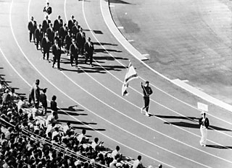
Carrying the Israeli flag in the Tokyo Olympics
But I was not enjoying a peaceful emotion as I marched into the Olympic stadium carrying the Israeli flag. I kept thinking that I had left my wife with our child alone in the hospital and anguished about the decision. Although I knew our friends, the Brodies, would take care of Yael and my daughter, I knew that it was not the same thing as having your husband and father around. I was unable to sleep at night or to concentrate during the discus practice sessions. I felt such tremendous guilt about leaving my family at such a vulnerable stage. As in Rome, emotions twirled and churned within me and my throwing attempts fell well short of my previous performances.
During the return trip to the US, I bought some souvenirs for Yael and my daughter. That was where my mind had dwelt. At the same time, I carried terrible guilt for failing to perform well. So many of my friends and mentors had cared and placed their trust in me to represent the country well. I felt that I had failed them as well for the second time. I had been extremely proud and happy about having earned another chance to participate in an Olympic game and felt devastated about performing so poorly. My only regret, then and now, was my inability to suppress my emotions and just throw.
After the Games, I returned to life at the University in Wyoming. Coach Walker helped me move my wife and daughter to student housing on campus. We could put our books and belongings down in one place called “home”. This was actually my first home.
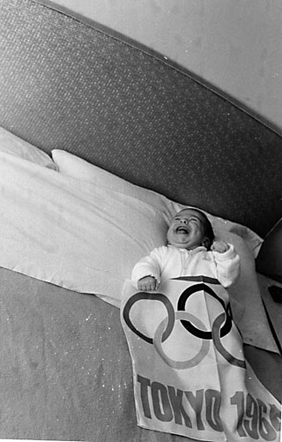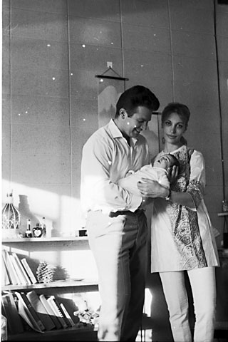
Geffen, Yael and I upon my return from the Tokyo Olympics
Now that I lived in student housing with my wife and child, Gilad, was alone in the Dormitory. He came to my house every day and we continued to study and train together. But, at the end of the day, he always had to return to the dorm room alone. I think my domestic situation made him feel homesick for the close family lives that most Israelis have.
One day Gilad came to me at the end of practice and showed me two photos of girls whom he had dated in Israel prior to coming to Wyoming. He told me: “Gideon, I am going back to Israel to get married. The problem is that I can’t remember which of these two girls is the one that has accepted my proposal. I have corresponded with Haya, but I can’t remember which picture is of her.”
“Anyway, I am going to Israel to marry Haya,” he said and “I am sure that she is one of the two pictures. I will be happy either way.” During the first school holiday break after this conversation, Gilad flew to Israel and married his beautiful wife, Haya. They are still married today.
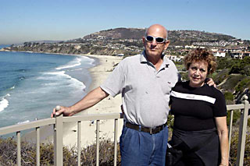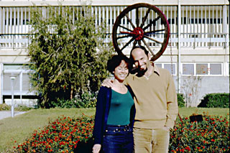
Gilad and Haya
When Gilad and Haya returned to Wyoming, we had a great time together at the University and with each other. My life had now expanded to include Gilad and Haya and we were all enthralled with the newness of the States and our success at school. Every day, Gilad and I continued to train and study hard. It was important that we maintain our scholarships and to do well academically. We were both very dedicated to both issues.
Of course, money was extremely tight for both of our families. The University stipend for student athletes was small. The money I received as part of my athletic scholarship at the University was $15 per week and was woefully inadequate for a family of three. Gilad and Haya were now the proud parents of a small son nearly the same age as my daughter. Neither of our wives was able to work because of the on-going problem with their visas. Visitor visa were only for visiting not for working. Marital status had no effect on the visitor’s ability to work. Therefore, neither Yael nor Haya was allowed to work because of the type of visa each had. Therefore, Gilad and I had to supplement our meager athletic incomes with a variety of jobs. We moved furniture for a local company, cleaned cars, painted houses, and cleaned the gymnasium after basketball games.
Life for Yael and I had ups and downs as with every married couple. Not only was money tight, there were enormous language and culture barriers for all of us, but more so for our wives than for Gilad and I. Our wives had young children to care for all day while Gilad and I had our classes, training, and study demands. We were immersed in our “jobs” at the university and had few spare moments to spend in normal family life. In retrospect, it is easy to account for many of the problems that arose, but, at that time, there were frequent squabbles and arguments.
During each summer vacation, I worked at a Jewish summer camp in Elbert, Colorado. The Camp’s name was JCC (Jewish Community Center of Denver.) The first year I worked as a Unit Head and was assigned children ranging in age from 10 to 13 years. We had variety of normal camp activities as well as some that reinforced the values and content consistent with a Jewish theme. Of course, I concentrated on athletic events which the kids loved. This was a beautiful environment in the mountains with nearby lakes. Yael, my wife, was the Arts and Craft director and she taught all types of art skills such as painting, clay modeling, and Israeli dancing. Thus, this summer work provided an opportunity to supplement our family income and in a beautiful natural setting.
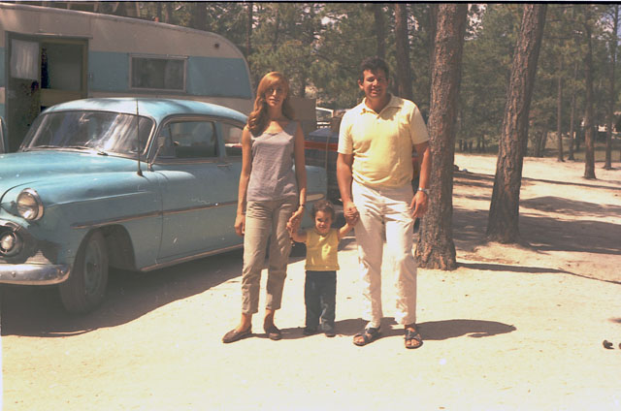 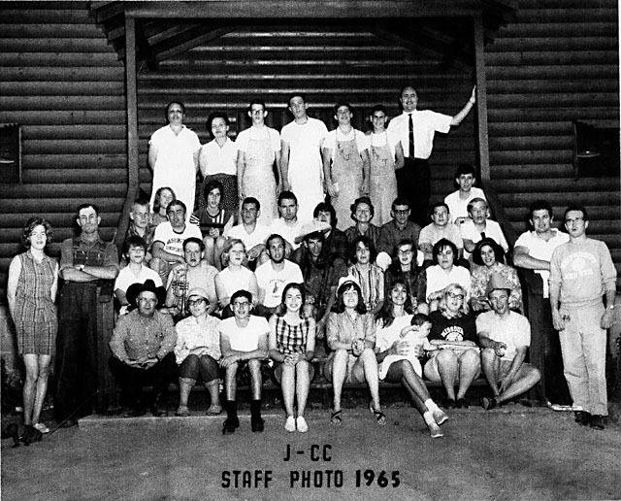
Yael, Geffen and I at Camp JCC of Denver Staff Photo of the JCC camp at 1965
During the subsequent school years, Gilad and I were each taking increasingly more difficult classes. Each semester, the courses that I took were increasingly more scientific. One day, as I walked by the computer center, I was struck by the power of the University mainframe. Most of the projects that the university worked on were associated with oil drilling since Wyoming had vast resources of petroleum. In fact, a large portion of the support for the athletic program was derived from oil royalties to the University. It was here that a small kernel of thought was planted with the nascent realization of the potential power of computers. I had not yet developed an idea for computer assisted training programs but I could envision the computer analyzing movement of all sorts.
I continued with ideas to enhance the fitness and strength for athletes. In the weight room, when a lifter wants to perform a bench press with a heavy weight, he needs two “spotters”. The purpose of the spotters is to assist the lifter with the weight if he is unable to execute the movement. Otherwise, the weight could crash down onto the athlete’s chest and cause injury. Using spotters allows people to try to increase the amount they lift in a safe manner. I devised a mechanism to help in spotting movements with heavy weights without having to interrupt two other people during their training or for those times when no one else was in the weight room. The device I created employed posts on both sides of the bench with holes into which selector pins could be inserted. Then if the person lifting was unable to complete the exercise there was no concern about dropping the weight since the pins projecting out from the posts would stop the weight. This was one of the first “selector systems” for weights ever created. No one knew about this safety device other than the athletes and I who worked out in the weight room on a daily basis. I did not think of this invention as “product” that could be bought and sold. All I knew was that it could help the athletes to lift heavy weights safely and free them from relying on spotters.
As older athletes who had both served in the Army, Gilad and I were respected and mentored many of the younger team members. Although in some cases, we were only 3 or 4 years older, but those age differences can seem greater if you have also served your country or performed in the Olympics. We were also more focused on our studies since we had passed the having fun and dating stage. Now our eyes looked beyond the undergraduate stage and onto the next step of graduate school.
At the beginning of our senior year, we went to the book distribution center to receive our text books for the year. The student athletes received free books as part of the scholarship stipend. Gilad and I, as well as most of our track and field friends, arrived early to stand in line so we could receive the newer books. Those students at the end of the line usually had well-used books filled with writings in the margins and broken spines. Just when the faculty member arrived to hand out the books, all of the football team members swarmed into the room, pushing everyone out of the way, and stood at the head of the line. This pushing and shoving to the front of the line proceeded with no resistance by any of the displaced athletes. Since Gilad and I were at the front of the line, we refused to move and asked what the football players were doing. The answer shocked us. Football was considered the most elite sport and, therefore, the players ranked ahead of everyone else. Therefore, they received their text books first.
Needless to say, this was a completely unacceptable situation and attitude for Gilad and me. Not only did we refuse to move, we blocked anyone and everyone from receiving any of the text books. The irate football team sent a representative to the Athletic Director, Mr. Jacoby, who was at the top of the athletic pyramid. When he came to the room, Gilad and I explained the current system and explained that this was inequitable. We argued that the only fair system should be “first come first served” rather than preferential treatment for football. Mr. Jacoby agreed and established the policy that the books were to be distributed accordingly. The first people in the line were to receive their books first and there was to be no preference by sport. Following the cheers from the track and field athletes and all of the other minor sports members, the books were distributed. Gilad and I made sure that all of the people, who had been in line ahead of us, received their books before we collected ours. The football team members, as the last to arrive, collected the old, broken text books.
This was how I spent the 3 years of my undergraduate studies. I studied intensely, trained diligently, and traveled all over the western parts of the US. The states in the western part of America are much larger in size than those on the Eastern seaboard. The Western Athletic Conference at that time consisted of the University of Arizona, Arizona State, Brigham Young University, University of Utah, University of New Mexico, and University of Wyoming. Therefore, when the track athletes competed against these schools at their home locations, we would spend many long hours driving to and from the competitions. Gilad and I participated in these competitions throughout the Track and Field season which covered most of the Spring Semester. We enjoyed every second of this opportunity to see vast stretches of America and considered ourselves fortunate for having such a chance.
One year, the competition in Las Cruces, New Mexico happened to take place during the Jewish holiday of Passover. This holiday begins with a special meal, called the “Seder”, and is an extremely important event for Jews. It was not that Gilad and I were especially religious, but the tradition and joy of the occasion, which is celebrated in a family and home setting is something very special. As two Israeli fellows in America, we very much wanted to enjoy this celebratory meal even if it meant that we were with people that were new to us. There is a special camaraderie among Jews on this day at this event. Of course, we knew no one in Las Cruces so we decided to look for “Ariel” in the telephone directory. There were none. Next we look for “Weingarten” and were surprised to find one. We called the number listed in the phone book and explained our situation to the man who answered the phone. Needless to say, the fellow was tentative about two strange men asking if they could come to his home for the Seder. He agreed to come to the university to meet us. When Mr. Weingarten arrived and discovered our legitimacy, he graciously invited us to enjoy the Seder with his family.
The next evening, scrubbed and happy, we went to Mr. Weingarten’s house. During the Seder meal, the conversation turned to where people had come from and how they got to where they lived then. We related about our arrival at the university in Laramie. There were about dozen Weingarten family members and suddenly came the shocking discovery that one of the ladies was directly related to Gilad. Gilad’s mother was this woman’s cousin. There were tears of joy and immediate phone calls to Israel. Each of the family members had thought the other one had been killed in the Holocaust. After this unexpected revelation, we really celebrated this fantastically happy and joyful Seder. Not long after this surprising discovery, the families traveled to Israel for a joyful reunion and they have continued this tradition in the intervening years.
The next day following this amazing discovery, Gilad and I were again at the university competition. Then the team drove back to Wyoming. Throughout the drive, we continued to chat about the remarkable events of the past several days and the knowledge that Gilad had more family than he had known existed.
Gilad and I were excellent students and after four years of study, we were ready to graduate. Our hard work and diligent efforts had paid off since we earned our degrees with Honors. From a maximum of 4.0, my grade point average was 3.8 and Gilad’s was 3.9. Not only were we to receive our Bachelors of Science with Honors, but we were entitled to wear a special blue tassel and to sit on the dais during the presentation of degrees.
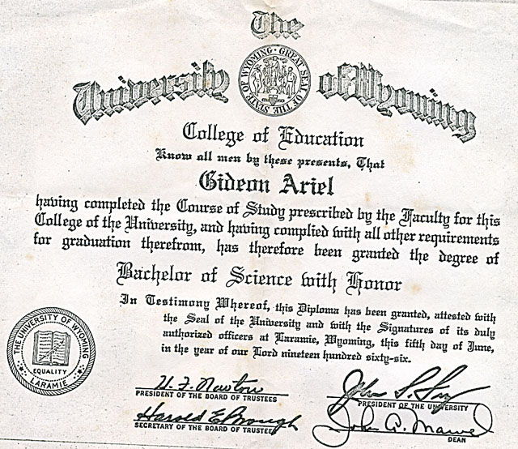
Graduating with Honor from the University of Wyoming
Several days before the graduation, we received our caps and gowns. Once again, we faced an American-made dilemma.
“What are these ‘dresses’ that they had given us to wear?” I asked Gilad. “What do we wear under them?”
Gilad confidently answered “Underwear, of course.”
On graduation day, we sat proudly on the dais while the ceremonies and speeches went on around us. Suddenly, I noticed that the other men on the stage beside us and the ones I could see in the graduating classes had long pants under their gown. I furtively pointed this out to Gilad who sat next to me on the stage. Here were the only two members of the Track and Field team that were graduating with honors and from beneath our graduation gowns were bare hairy legs above our while socks and black shoes. We struggled to surreptitiously pull the gowns down as far as they would stretch, but I doubt we fooled anyone who noticed our sartorial faux pas! Still, this clothing malfunction did nothing to subdue our joy or the success of our efforts.
At the ceremony, Coach Walker gave a speech about how Gilad and I had performed and how far we had developed during the time since he had first met us. Our fellow teammates applauded us and we were both extremely happy. Our wives in the audience beamed with pride as well. Even Geffen watched with great interest as her father fiddled with his gown on the stage. Fortunately, at the age of one and a half years, she was not independently skilled about dress either.
During our senior year, Gilad and I had discussed at length about where we would go to continue our education following graduation. I mailed at least 25 applications to various Universities requesting an assistantship so I would be able to continue my studies toward an M.S. Degree. Gilad was accepted at the University of Minnesota since he had decided that psychology was the most interesting field of study. I was offered an assistantship at the University of Massachusetts which I accepted since that school appeared to offer the greatest range of scientific options.
So, following our June 1966 graduation, Gilad and Haya said good bye and left for Minnesota. There were many mixed feelings in my head as I watched my friends drive away to their new home. Gilad and I had spent so much time together and now, in an instant, he was gone. In addition to our many hours of athletic practice and competition times, he was also my study partner and ally. Now, I had no one to share these academic quests since Yael was not at all interested in studying.
But, I was happy after four years of work, study, and athletics and rejoiced about the challenge ahead of me. I had overcome every obstacle before and, with these thoughts, Yael and our daughter, Geffen, began the trip in our 1961 Plymouth from Laramie, Wyoming to Amherst, Massachusetts. We left those wonderful Rocky Mountains and drove east to settle in the Berkshires. The size and extent of the mountains may have differed but we began to encounter new peaks -- not only for ourselves but for the whole industry of athletic training.

